Game Design Document

Fill up the Following document

1. Write the title of your project.

Ans : Shuttle cock game

1. What is the goal of the game?

They have to score 5 points

1. Write a brief story of your game?

**Shuttle** is a racket sport played by two opposing pairs (doubles), who take positions on

opposite halves of a rectangular court that is divided by a net.

1. Which are the playing characters of this game?

* Playing characters are the ones which respond to the user based on the input from the user
* Cars, monkeys, dinos, wizards etc, are the playing characters in the game.

|  |  |  |
| --- | --- | --- |
| Number | Character Name | What can this character do? |
| 1 | Player 1 | Player 1and 2 will play with player 3 and 4 |
| 2 | Player 2 | Player 1and 2 will play with player 3 and 4 |
| 3 | Player 3 | Player 1and 2 will play with player 3 and 4 |
| 4 | Player 4 | Player 1and 2 will play with player 3 and 4 |
| 5 | Umpire | Will tell the score |
| 6 | Coach 1 for player 1 and player 2 | Coach 1 will guide player 1 and 2 |
| 7 | Coach 2 for player 3 and player 4 | Coach 2 will guide player 3 and 4 |
| 8 | Spectators | They will encourage players |

1. Which are the Non Playing Characters of this game?

* Non Playing characters are the ones which don't have an action or a behaviour when the user interacts with the game.
* Hurdles, stones, bananas, coins, etc are non playing characters in the game.

|  |  |  |
| --- | --- | --- |
| Number | Character Name | What can this character do? |
| 1 | Spectators | They will encourage players |
| 2 | Cock | It is used to play |
| 3 | Net | It is used to say that who will get the score and also to separate the team |
| 4 | Water bottle | It is used to refresh the players |
| 5 | Court | It is used to help the players were to stand |
| 6 | Racket | It is used to hit the cock |
| 7 |  |  |
| 8 |  |  |

Draw your imagination of this game. What does this game look like?

* Draw the game either on your computer or on paper,
* Add images of scenes of the game to show each of the playing and non-playing characters at least once.

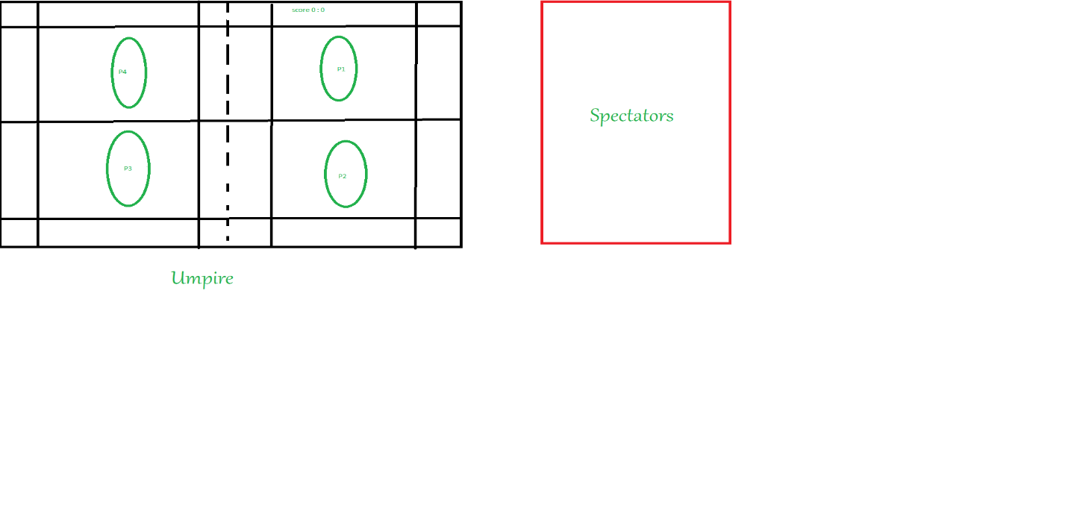

How do you plan to make your game engaging?